

**Micro-Credit Defaulter Model**

Submitted by:

CHITRAK SATYARTHI

**ACKNOWLEDGMENT**

This includes mentioning of all the references, research papers, data sources, professionals and other resources that helped you and guided you in completion of the project.

**INTRODUCTION**

* Business Problem Framing

There are lot of people who don’t pay the loan amount due to various reasons but as per the company it is just related to loss/ profit. If a customer is not paying the loan amount it is loss to the company. If we relate to real world, loan has been a good way of earning profit and having customer loyalty. Example – Banks are making profit through loan repayment else it becomes LPA, having a bank account and the amount in that bank account is a liability to bank as they had to return the money whenever asked by the customer but giving loans with some interest is the way banks make profit.

* Conceptual Background of the Domain Problem

Loan repayment has always been a concern to the companies as it is a risk which is taken by the company. If the loan is not paid then it is the total loss to the company. But to make customer stick to the brand and to provide services to the customers, companies has to take these kind of decisions and steps so that customer should feel that company is concern about their situation by giving these options.

* Review of Literature

When these kind of situations are in front of the companies then they had to go through various decision making which can help the company to have a better understanding of the decision they have made and proceed according to that, as here is the situation of loan repayment. This situation has always been a challenge for the company because if the loan is not paid it will be a total loss to the company. When it comes in providing services to the customers then it becomes a challenge for the company to prevent the losses.

* Motivation for the Problem Undertaken

For me any challenging situation and problem act as a motivation as well as a big problem which is connected to the real life situation of the company on which my study can act as an solution to the company.

**Analytical Problem Framing**

* Mathematical/ Analytical Modeling of the Problem

In the current problem statement each and every analysis is related to the key variable which is “Label” and analysis/ relating it with other variables gives a clear view that who will be the users which will repay the loan and continue with the services.

* Data Sources and their formats

The data with the variable which were provided in the csv file are necessary and were enough to analyse to make a decision.

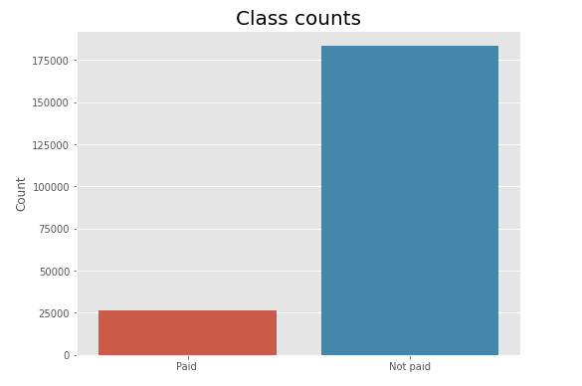

* State the set of assumptions (if any) related to the problem under consideration

All the variables were compared with a key variable “label” to analyse the loan repayment made by the users.

* Hardware and Software Requirements and Tools Used

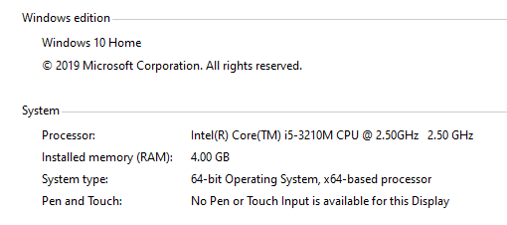

**Model/s Development and Evaluation**

* Identification of possible problem-solving approaches (methods)

Train Model

* Visualizations

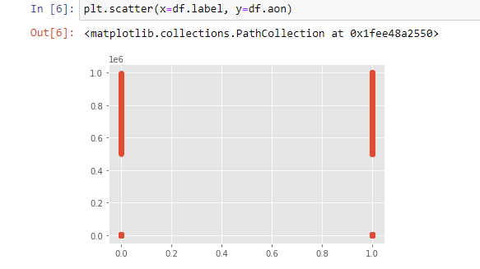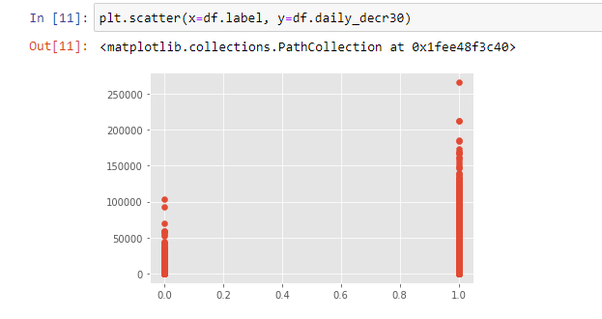

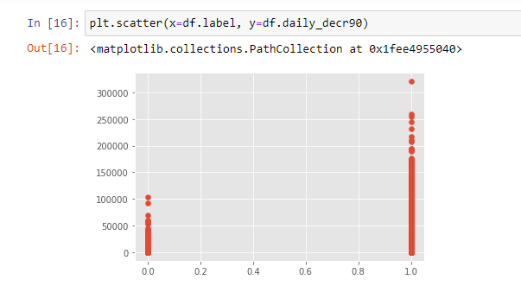

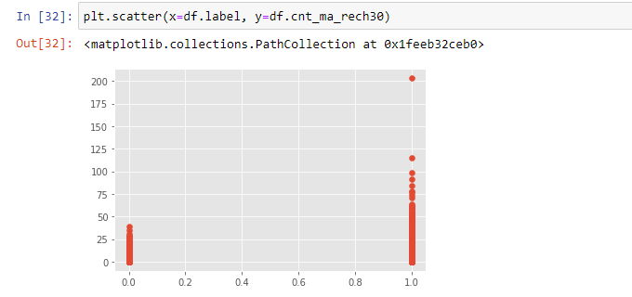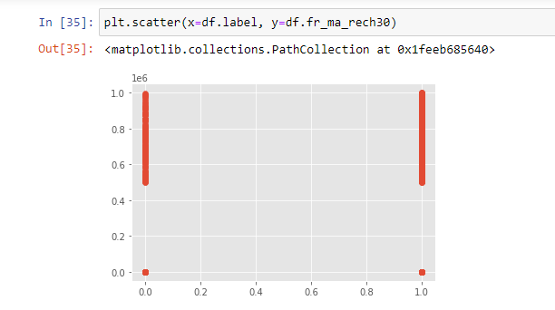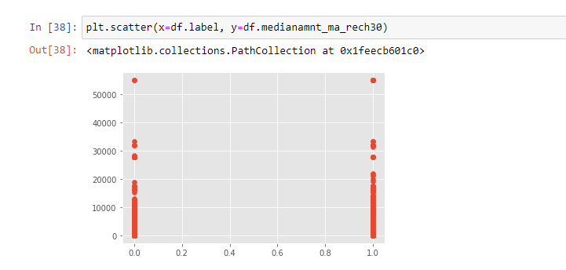

**CONCLUSION**

* Limitations of this work and Scope for Future Work

When it comes to analysis it can always be done in a better way but according to my analysis this every variable I have related with constant “label” and had predicted the output. The users for whom using data and calling is really necessary they are making the payment.